Make up sentences from these words (составьте и запишите предложения из слов).
1. at/ mum/ cooking/ good/ is /Jane’s.
2. in/ how/ you/ many/ your/ do/ textbooks/ have/ bag?
3. is/ interesting/ English/ the/ subject/ at/ most/ school .
4. the/ any/ in / are / trees /there/ schoolyard?
5. have/ days/ last/ we/ many/ didn’t/ sunny/ summer.

1. ____________________________________________________________
2. ____________________________________________________________
3. ____________________________________________________________
4. ____________________________________________________________
5. ____________________________________________________________
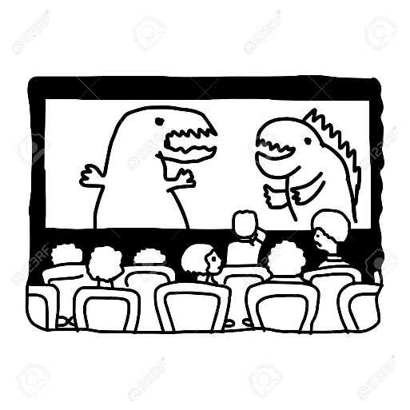
Задание 4. Письмо
Last weekend you went to the cinema.
Write a short note (записка) to your friend.

In your note
- tell your friend who you went with;
- tell your friend what the film or the
cartoon (мультфильм) was about;
- tell your friend why you liked it;
- invite (пригласи) your friend to go to the cinema with you next weekend.

Write 45 – 50 words (45 – 50 слов)

Dear ______________,
I went to the cinema last weekend.
________________________________________________________________
________________________________________________________________
________________________________________________________________
________________________________________________________________
________________________________________________________________
________________________________________________________________
________________________________________________________________
________________________________________________________________

See you,
___________________

December 7, 2019

Открытая олимпиада по иностранным языкам
для учащихся 4-5 классов
Английский язык
5 класс
КЛАССИКА

Фамилия, имя участника _________________________________

№ школы, город __________________________________________

Enjoy the competition and good luck to you!

Задание 1. Аудирование

What birthday presents did Sarah get from her family?
Напишите нужную букву A – H в таблице.
Два подарка в списке лишние.
1. David |  | 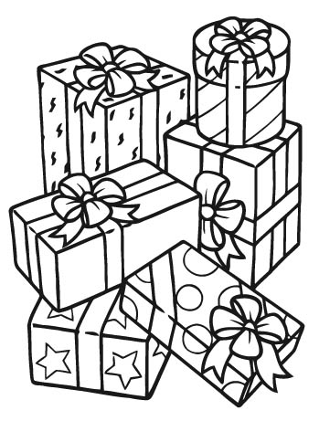  A. paints  B. a ball  C. a t-shirt  D. a pencil case  E. socks  F. a toy elephant  G. a bag  H. a book
2. Michael

3. Uncle John

4. Aunt Sue

5. Jane

6. Anna

Задание 2. Чтение
My first day at school
My name’s Betty Stuart and I’m an English teacher. I was twenty-two years old when I got my first teaching job. Now I’m thirty-two and I remember my first day at school very well.
That day didn’t start well. I got up early and got dressed. Then I dropped* my cup of tea all over my new skirt. I put on clean clothes, took my bag and went to the bus stop. I saw a lot of people there. I asked a woman, “Why are there so many people?” She said, “There are some transport problems in the city centre and all the buses are late.’ So, I thought it was better to walk to school.
I only had half an hour before my first lesson. I walked very quickly. After some time I could see the school at the end of the road. I felt very happy.
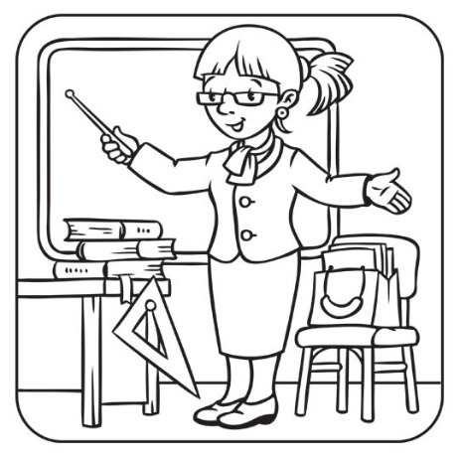
Suddenly it started to rain. I ran fast but I was very wet when I got to school.
When I came into my classroom I looked wet and felt very bad. At first, my students looked surprised when they saw me. Then they all smiled and said, “Good morning Miss Stuart!” I smiled back and said, “Good morning class!” After that the day was much better.

*drop – уронить

Заполните пропуски в предложениях по тексту словами.
Можно использовать от 1 до 3 слов.

1. Betty’s job is a teacher of _______________________.
2. She started teaching _________________________________ ago.
3.Betty couldn’t wear her new skirt to school because she had ____________________ on it.
4. There were ______________________________at the bus stop.
5. A ____________________ told Betty about transport problems.
6. Betty was __________________ when she could see the school.
7. Before Betty got to school it _______________________ rain.
8. The rain made Betty _______________________.
9.The students were surprised when they saw their new _______________.
10. Everybody in the class ____________________ at Miss Stuart and said, “Good morning!”

Раскрасьте картинку:
- Betty’s skirt is blue.
- The chair is yellow.
- Betty’s bag is purple.
- The classroom floor is brown.
Дополните картинку рисунками в соответствии с предложениями:
1. You can see the word FUN on the board.
2. There is a clock on the wall.
3. There is a red apple on the books.

Задание 3. Лексика и грамматика
Обведите в кружок правильный ответ:

1. It is very interesting to learn … life under the sea.
a) for b) how c) about

2. The biggest animals that live in the sea … whales.
a) is b) are c) have

3. Blue whales are very big - … than dinosaurs that lived in the past.
A) more big b) bigger c) the biggest

4. The blue whale can be 30 metres ….
a) long b) fat c) short

5. … are whales in all the seas and oceans.
a) They b) Their c) There

6. Dolphins also … in the sea and in the ocean.
a) lived b) will live c) live

7. Dolphins are friendly … they can swim with people.
a) but b) or c) and

8. People like … with dolphins.
a) swimming b) swim c) will swim

9. But … would like to swim with a shark.
a) everybody b) anybody c) nobody

